=

Public holiday Guide
  - Nurses and MIDWIVES
victorian hospital's industrial association – FEB 2024

introduction
The purpose of this Public Holiday Guide is to replace the previous Public Holiday Matrices and summarise the public holiday entitlements afforded to employees under the Nurses and Midwives (Victorian Public Health Sector) (Single Interest Employers) Enterprise Agreement 2022 – 2024 (Agreement) for the remaining life of the Agreement until it is replaced.
Members will no longer receive multiple Public Holiday Matrices throughout the year, rather members can use this document to prepare for all public holidays for the remaining life of the Agreement.
VHIA has detailed the known public holidays that occur between the publication date of this Public Holiday and the nominal expiry date of the Agreement, 30 April 2024. VHIA will provide updated advice to members closer to that date where the Agreement is anticipated to operate beyond the nominal expiry date.
It is not intended to replace the Agreement or provide an entitlement beyond the Agreement itself.
VHIA encourages members to read the relevant terms of the Agreement alongside this Public Holiday Matrix.

where to find copies of the agreement and other material
VHIA members can access copies of the Agreement and other material (such as Implementation Guides and Salary Circulars) by selecting Nurses and Midwives under ‘My Professions’ on your VHIA Website Dashboard.
For more information about accessing the VHIA Website, please contact vhia@vhia.com.au

WHO TO CONTACT FOR MORE INFORMATION
Members are encouraged to direct any queries in relation to this Public Holiday Guide to query@vhia.com.au

working on a public holiday
Relevant Clause
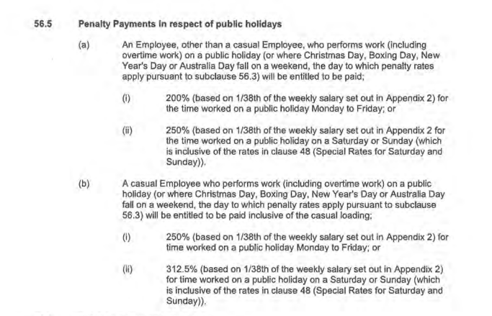
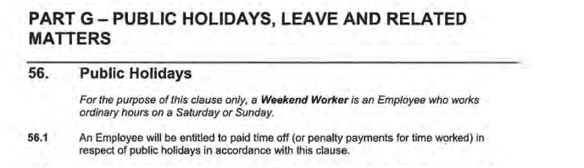

working on a public holiday- NIGHT SHIFT
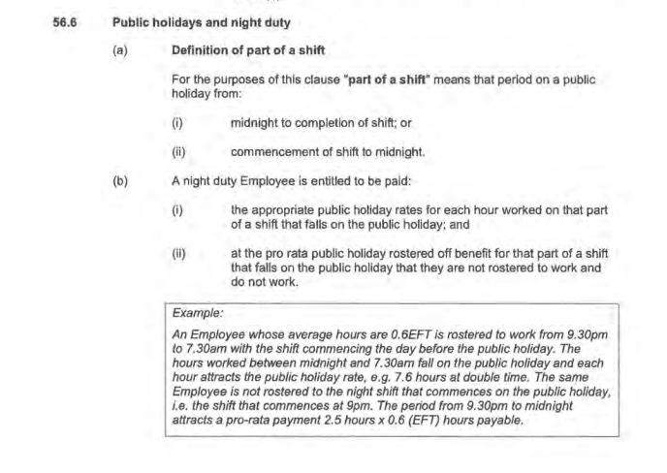

not working on a public holiday – FULL TIME
Relevant Clause
Note: The definition of Actual Day and Other Day can be found summarised below under Additional Rules – Public Holidays falling on a Weekend
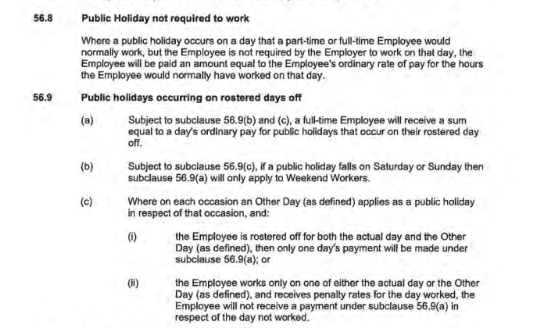

not working on a public holiday – Part TIME
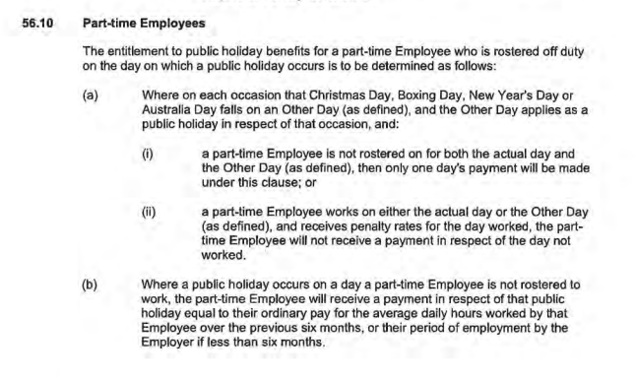

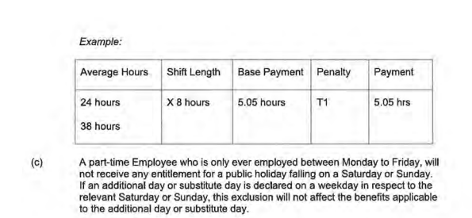

additional rules – public holidays falling on weekend
Relevant Clause
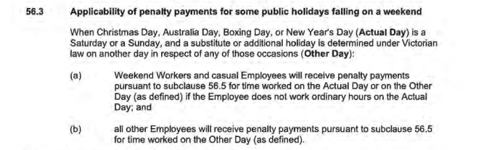

additional rules – other leave on public holidays
Leave Type | Impact of taking leave on a Public Holiday
Annual Leave | If an Employee takes paid annual leave during a period that includes a public holiday, the Employee is taken not to be on paid annual leave on that day. – see sub-clause 57.7 (a)
Personal Leave | If the period during which an Employee takes paid personal leave includes a day or part day that is a public holiday in the place where the Employee is based for work purposes, the Employee is taken not to be on paid personal leave on that public holiday– see subclause 61.7
Long Service Leave | Long service leave is inclusive of (not additional to) Public Holidays that occur during the relevant period of leave - see subclause 70.9
Paid Parental Leave | An Employee on Paid Parental Leave when a public holiday occurs does not receive a public holiday entitlement, nor does it extend the Paid Parental Leave period
Unpaid Leave | If an employee is on Unpaid Leave when a Public Holiday occurs, the employee does not receive a public holiday entitlement.

additional rules – recall on public holiday
Relevant Clause
Note: This clause provides that a Nurse/Midwife who has an entitlement to a public holiday benefit on a day they are not working will be guaranteed the rostered off benefit afforded to them under subclause 56.8, 56.9 or 56.10 in addition to any recall payment they receive – regardless of the time of the day the recall occurs.
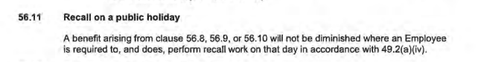

Table 1: Summary of Public Holiday Entitlements
Night Shifts: Note the additional rules regarding public holidays and night duty at subclause 56.6
Full Time | Entitlement | Clause Ref.
Rostered to Work (works on public holiday) | 200% or 250% if it falls on a Saturday or Sunday | 56.5
Rostered to Work (not required to work) | 1 days ordinary pay at the rostered hours for that day | 56.8
Not Rostered to Work (rostered day off) | 1 days ordinary pay (7.6 hours unless they ordinarily work longer shifts)  Weekend PH (e.g. Easter Saturday and Easter Sunday):  Employees who are Weekend Workers receive the Not Rostered to Work benefit set out above (100%)  No rostered off penalty applicable if the employee is not a Weekend Worker  Weekend Worker means an Employee who works ordinary hours on a Saturday or Sunday | 56.9  56.9(b)  56

Part Time | Entitlement | Clause Ref.
Rostered to Work (works on public holiday) | 200% or 250% if it falls on a Saturday or Sunday | 56.5
Rostered to Work (not required to work) | 1 days ordinary pay at the rostered hours for that day | 56.8
Not Rostered to Work (rostered day off) | Weekdays & Weekend PH (including Easter Saturday)  Pro-rata payment, equal to their ordinary pay for the average daily hours worked by that employee over the previous six months (e.g. 24  /38 x 8 hours (or usual shift length) = 5.05 hours.  E.g. a part-time Employee who is only ever  employed between a Monday to Friday, will not receive any entitlement to Easter Saturday or Easter Sunday. | 56.10,  56.6(b)(ii) for Night Shift Nurses

Casual | Entitlement | Clause Ref.
Rostered to Work | 250% or 312.5% if it falls on a Saturday or Sunday | 56.5(b)
Not Rostered to Work | No rostered off benefit unless they are required to work on that day | 62.3

Table 2: public holidays occuring until nominal expiry date
Note: Public Holidays falling on a weekend are marked in bold
2024
New Years Day – 1 January 2024 | Australia Day – 26 January 2024
Labour Day – 11 March 2024 | Good Friday – 29 March 2024
Saturday before Easter Saturday – 30 March 2024 | Easter Sunday – 31 March 2024
Easter Monday -1 April 2024 | ANZAC Day – 25 April 2024
King’s Birthday – 10 June 2024 | Friday before AFL Grand Final – 27 September 2024
Melbourne Cup – 5 November 2024^{i} | Christmas Day – 25 December 2024
Boxing Day – 26 December 2024
Source - Victorian public holidays 2024 | Business Victoria

